Python Exercise - 2026/08/06

Question 01
- Write a Python program to input the first character of a shape:
- R – Rectangle
- T – Triangle
- C – Circle
- The program should calculate and display area of the selected shape.
- Use the following inputs and formulas:
Shape | Inputs | Area Formula
Rectangle (R) | Width, Length | Area=Width × Length
Triangle(T) | Base, Height | Area=(Base × Height)/2
Circle (C) | Radius | Area=π × Radius²

- Requirements:
- Ask the user to enter first character of the shape(R,T or C)
- Based on the selected shape, input the required values.
- Calculate the area using the correct formula.
- Display the calculated area.
- Program
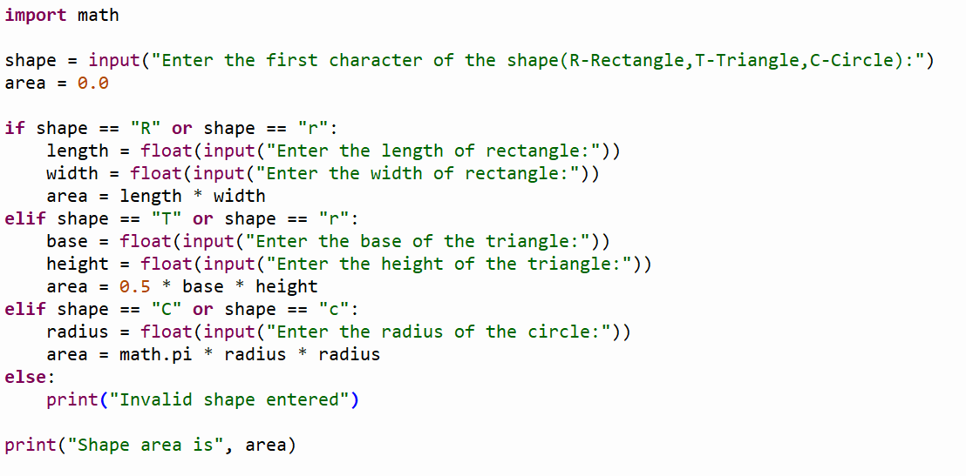
- Outputs

- Correct Cases

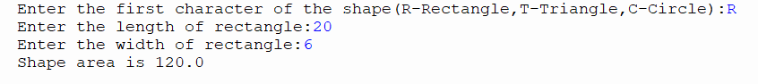

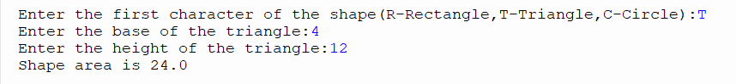

- Wrong Case

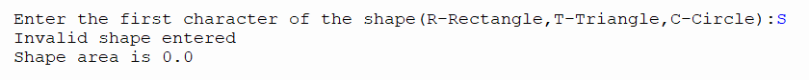

Question 02
- An Adventure Resort offers the following activity packages:
Package Type | Title | Cost per Person (Rs.)
1 | Horse Ride | 2000
2 | Scuba Diving | 5000
3 | Water Rafting | 7000

- Write a Python program to:
- Input the package type (H, S or W) from the keyboard.
- Input the number of people.
- Use if…elif…else statements to determine the cost per person.
- Calculate the total cost using the formula:
- Total cost = Cost per Person × Number of People
- Display:
- Package Title
- Cost per Person
- Number of People
- Total Cost
- Note: Use if… elif… else statements only.
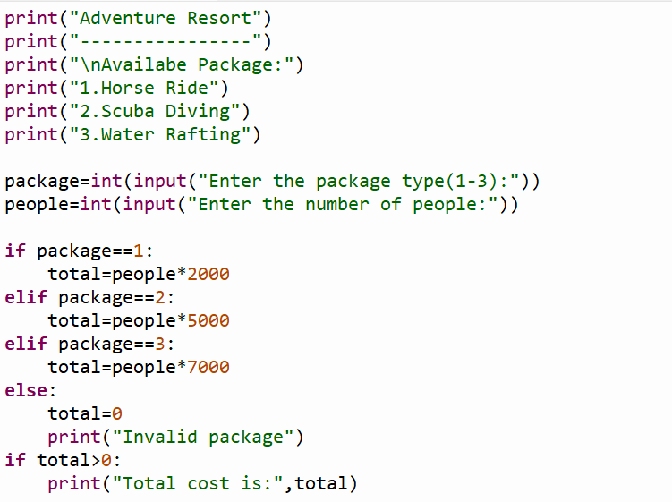
- Program

- Outputs

- Correct Cases
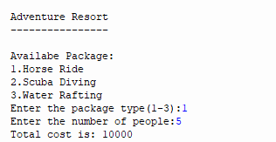

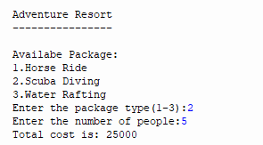

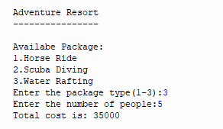

- Wrong Case
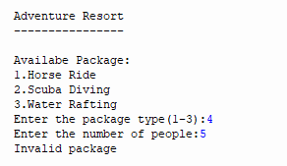

Question 03
- Write a python program to input values for three angles and display whether a triangle can be formed or not using given angle values.
- Hint: To form a triangle, the summation of all three angles should be equal to 180 and all three angles have to greater than 0 degrees.

- Program
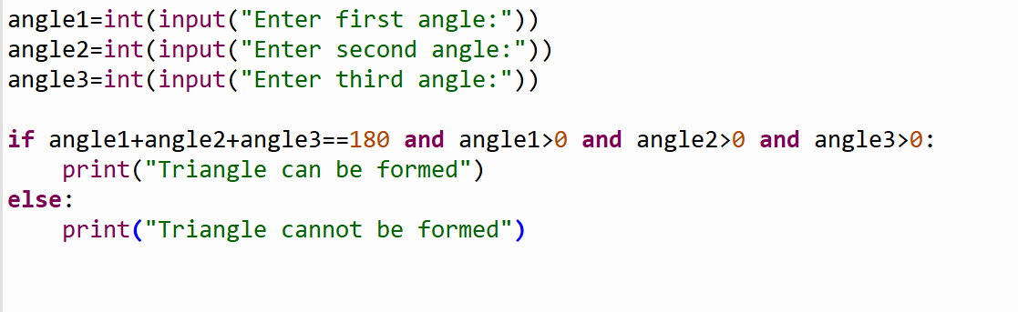

- Outputs
- Correct Cases
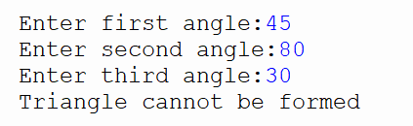

- Wrong Case

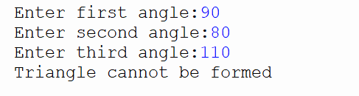

Question 04
- Create a simple calculator that perform basic arithmetic operations based on the user’s choice:

- Program
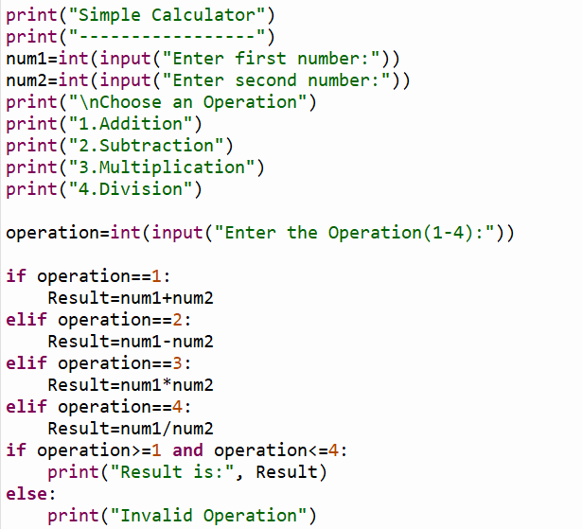

- Outputs

- Correct Case
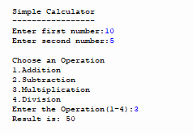

- Wrong Case

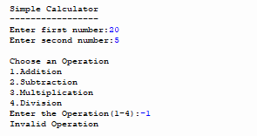

Python Exercise – 2026/08/10

Question 01
- Write a python program to display all even numbers between 0 and 20.

- Program

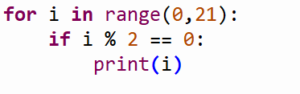
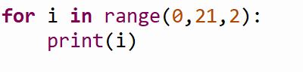

- Output
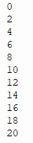

Question 02

- Write a python program to input the mark of 10 students and calculate the total and the average marks.

- Program
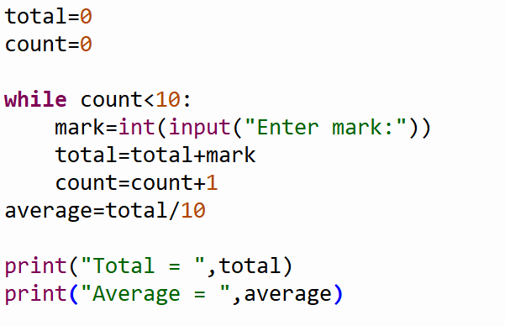

- Output

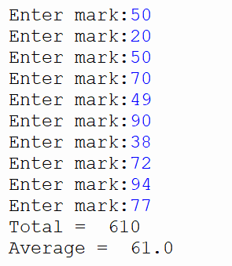
Question 03

- Write a program that prompts the user to enter a number and displays the multiplication table for that number up to a specified range.
- Program
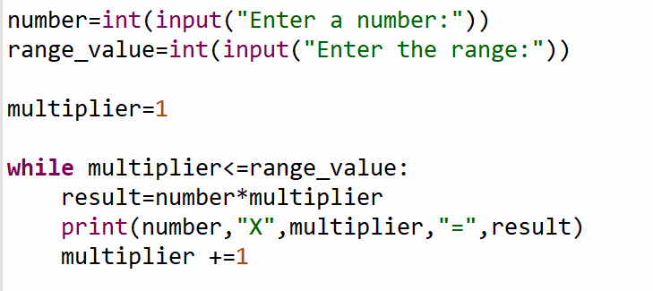

- Output
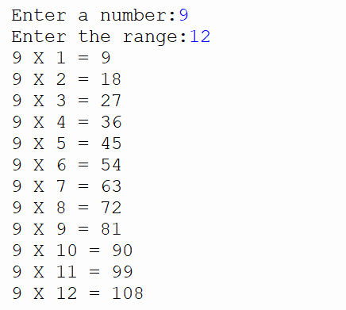
Question 04

- Write a Python program to input student’s marks one by one until the user enters -1. Then calculate and display the total marks and the average marks. If no marks are entered, display “No grades were entered”.
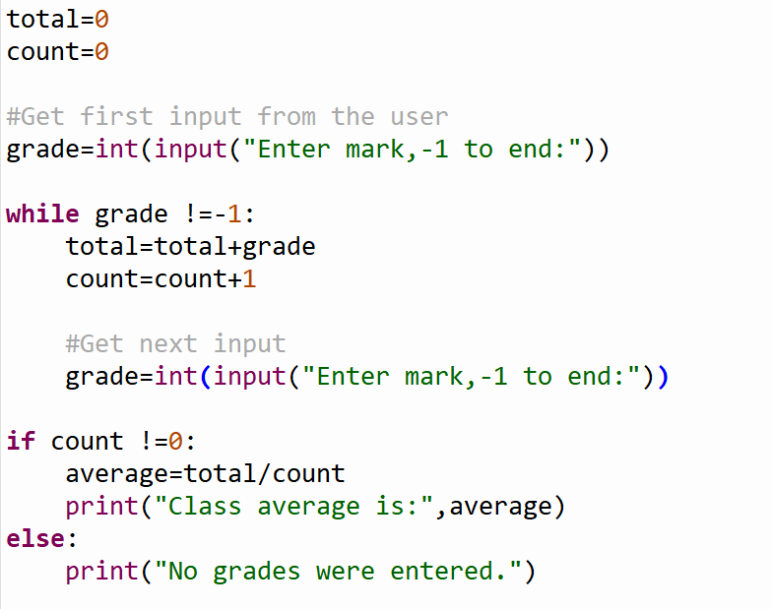
- Program

- Output

- Correct Case Wrong Case
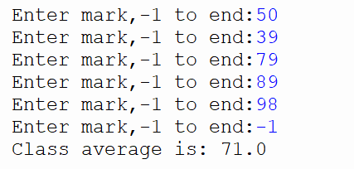
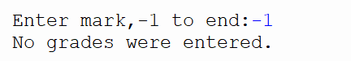
Question 05

- Write a Python program that prompts the user to enter a password. The user can attempt to enter the password a maximum of 3 times. If the correct password (password123) is entered, display “Access Granted”. If all 3 attempts are used without entering the correct password, display “Access Denied”. Use a sentinel-controlled repetition (or an equivalent loop in python).
- Program
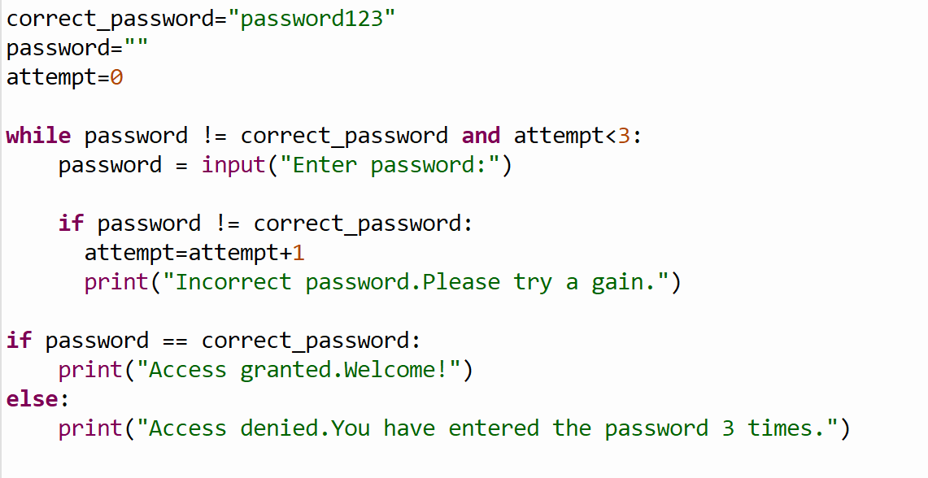

- Output
- Correct Case
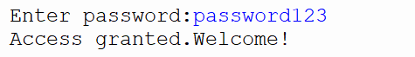

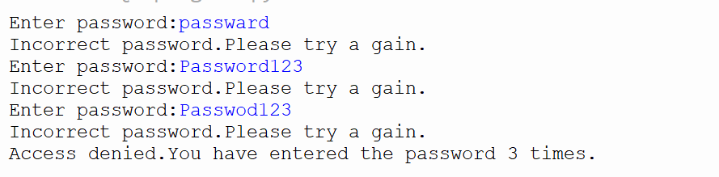
- Wrong Case
Question 06

- Write a program that prompts the user to enter a positive integer number. The program should calculate the sum of all numbers 1 to the entered number using a counter-controlled repetition with a do-while loop. Display the final sum.
- Program
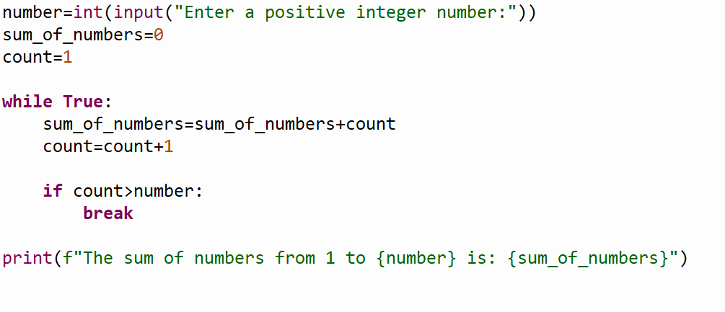

- Output

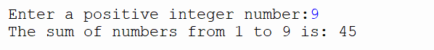

Question 07

- Write a program that prompts the user to enter a positive integer number, the program should calculate and display the factorial of the entered number.

- Program
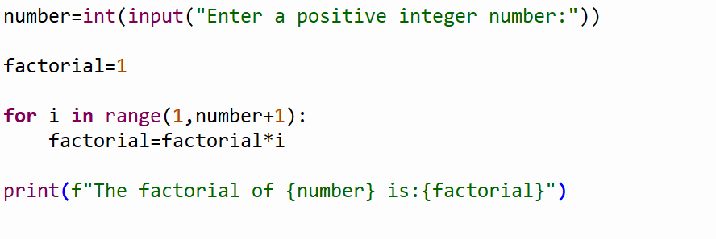

- Output

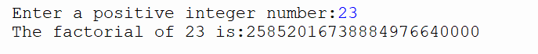

Python Exercise – 2026/08/13

Question 01

- Write a Python program to calculate the green-colored area where grass needs to be planted. Use Area Of Green (), Area Of Rectangle (), Area Of Circle () function to do it. And assume owner need to build fence therefore find the perimeter of the yard.

- Hint:
Shape | Inputs | Area
Rectangle | Width, Length | Width × length
Circle | Radius | Π × radius × radius

- Use appropriate functions, input values from the user, and display the calculated green and the perimeter of the yard.

- Program
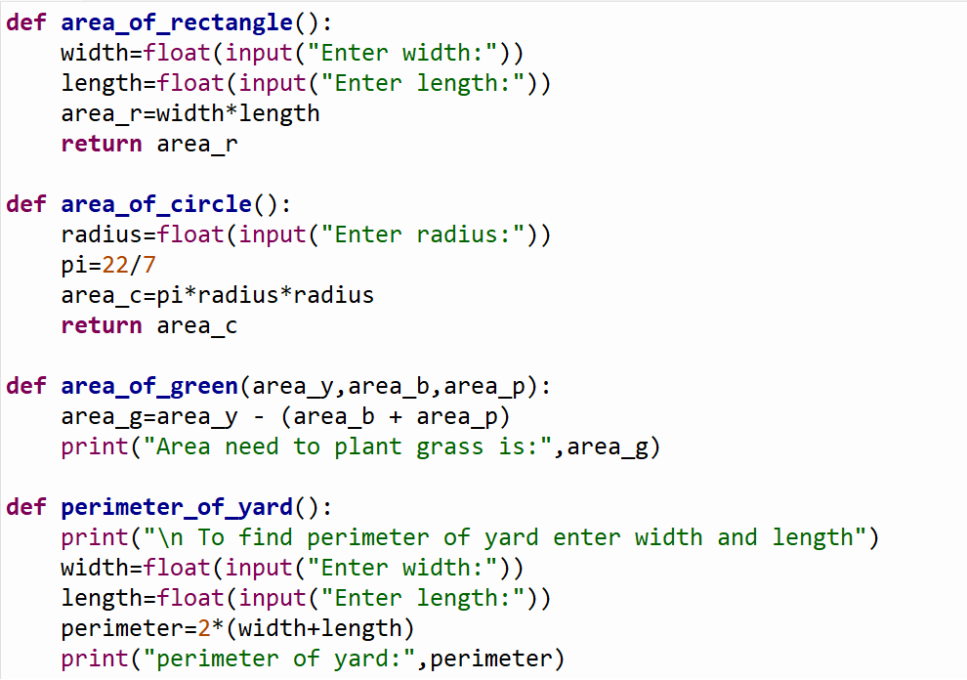
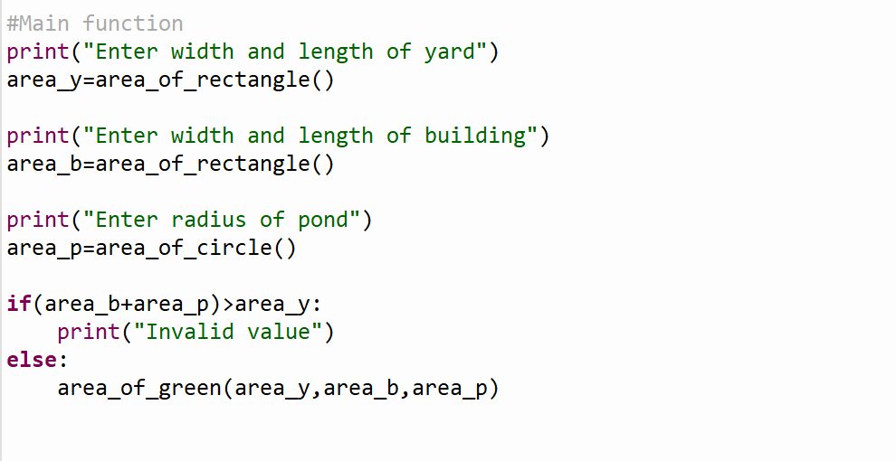

- Output

- Correct Case
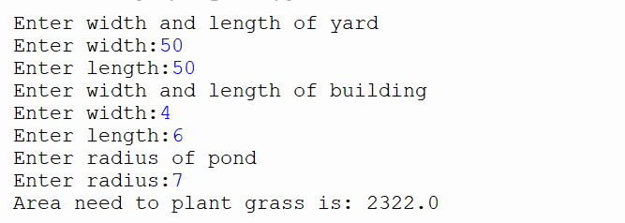

- Wrong Case
